**NATIONAL UNIVERSITY OF SCIENCE AND TECHNOLOGY**



**FACULTY OF INDUSTRIAL TECHNOLOGY**

**DEPARTMENT OF INDUSTRIAL AND MANUFACTURING**

**ENGINEERING**

**FINAL YEAR PROJECT [TIE5009]**

**For**

**TINASHE TANYARADZWA MABIKA (N01519975J)**

**SOIL MOISTURE PREDICTION FOR SMART IRRIGATION SCHEDULING**

**SUPERVISOR:**

# 

# DECLARATION

I, **TINASHE TANYARADZWA MABIKA** declare that:

The research reported in this dissertation, except where otherwise stated, is my original work.

This dissertation has not been submitted for examination for any degree at this or any other university.

This dissertation does not contain other persons’ writing, data, pictures or graphs except where acknowledged as having been sourced from the other persons. Where written sources have been used:

The words have been paraphrased and the information attributed to the source through referencing;

With exact words quoted, the writing has been placed in quotation marks and referenced.

**DECLARATION OF COPYRIGHT**

I hereby do not grant permission to the National University of Science and Technology Library to reproduce copies of this dissertation or to lend or sell such copies for private, scholarly or scientific research purposes.

I reserve other publication rights. No extensive extracts from this dissertation may be printed in any form or otherwise reproduced without my written permission.

**SIGNATURE: …………………………………**

**PERMANENT ADDRESS: 5289 Nkwisi Gardens, Tynwald, Westlea, Harare**

**DATE: ..............................................................**

# DEDICATIONS

# ACKNOWLEDGEMENTS

# ABSTRACT

Water balance is essential for high quality yields. Under-wateredcrops suffer from nutrient deficiencies while over-watered plants are more prone to diseases and can lead to root death through choking. Also, over-watered plantsare not able to withstand dry spells during dry seasons. Water-saving agricultural practices and sound watermanagement strategies are therefore required to ensureviability of the farming industry.

With great advancements in Internet of Things and Artificial Intelligence its high time we leverage the beauty of these technologies in Zimbabwe as it answers to most of the challenges we are facing. Reduction in production costs through automation of manual tasks, remote monitoring, high output yields and better land fertility are some of the advantages of applying these technologies into farming.

This study is aimed at developing a smartirrigation controller which acquires soil moisture contents, temperature, humidity, volume of water used, solar radiation and whether it’s raining or not. The controller cleans the signals, stores to a local database before storing to an online database. Server-side JavaScript controller fetches data from the database and feed to a dynamic artificial neural network (DANN) which responds with predictions of soil moistures for the coming days to the irrigation controller and decisions can be made to best optimize water to be irrigated. The controller is able to send SMS and email notifications to the farm operators. This data is also relayed to aweb application where it can provide valuable information to any operator concerned and can remotely control the irrigation processes.

The heart of the controller circuit isthe WeMos atmega2560 Wi-Fi based micro-controller that uses C++ as a high-level programming language. Message notifications are achieved by interfacing with sim800L GSM module. The dynamic neural network is made from MATLAB neural network toolkit.

# Table of Contents

DECLARATION i

DEDICATIONS iii

ACKNOWLEDGEMENTS iv

ABSTRACT v

Table of Contents vi

LIST OF FIGURES viii

LIST OF TABLES ix

CHAPTER ONE - INTRODUCTORY CHAPTER 1

1.0 Introduction 1

1.1 Background 1

1.2 Aim 3

1.3 Objectives 3

1.4 Scope 4

1.5 Justification 4

1.6 Methodology 5

1.7 Timeline 7

1.8 Summary 8

2 CHAPTER TWO – LITERATURE REVIEW 9

2.1 Introduction 9

2.2 Types of Agricultural Water Use 9

2.2.1 Irrigation 9

2.2.2 Rain-fed Farming 16

2.3 Specific Plant Water Requirements 16

2.3.1 Soil Moisture for Optimal Crop Growth 16

2.3.2 Seasonal Crop Water Needs 18

2.3.3 Drought sensitivity 19

2.3.4 Importance of Water to Plants 20

2.4 Control Systems 20

2.4.1 Types of Control Systems 20

2.5 Cloud Services 22

2.5.1 Types of Cloud Services: 22

2.5.2 Cloud Services Providers 23

2.6 Data Forecasting 23

2.7 Hardware 23

2.7.1 Micro-controllers and Processors 23

2.7.2 Communication 29

2.7.3 Data Storage 32

2.7.4 Sensors 33

2.7.5 Displays 41

3 Chapter three - Methodology 43

REFERENCES 43

# LIST OF FIGURES

Figure 1.1 Poor yield due to under irrigation (krcu.org, 2013) 2

Figure 1.2 Picture showing over irrigated land (Columbia.edu, ) 3

Figure 1.3 The Design and Development model. 6

Figure 1.4 Project Timeline 7

# LIST OF TABLES

Table 1.1 Scheduled timeline 7

# CHAPTER ONE - INTRODUCTORY CHAPTER

## Introduction

World climate change is causing a major blow on global water supplies. 70% of world’s fresh water is used for irrigation purposes, it is therefore important to develop and leverage trending technologies to monitor and control agricultural fields for sustainable and efficient water use (Victor et al., 2009). Irrigation should meet specific plant water demands to avoid overand under irrigation. This can be attained by performing irrigation operations basing on time, forecast and present soil moisture contents. Precision irrigation aims to find and quantify plant water needs in a smart way (Smith, 2011). This field of study is very helpful in estimating farming parameters like fertilizers and other input needsby assessing soil conditions, thus preventing inflexiblepractices in farming. The irrigation amount and timing is based on measurementsof soil, plant, and climatic variables from which the plant water need is inferred. Precisionirrigation and artificial intelligence applications have shown to improve water use efficiency, reduce energy consumption, and enhancecrop productivity by leveraging advances in control systems, and optimization algorithms.

## Background

With the drive to rebuild and grow our economy, it is now imperative that we utilize our abundant resources on the agricultural front. Agriculture occupies a central space in the Zimbabwean economy and has the potential to significantly reduce poverty, enhance economic growth and with time entrench economic stability.

According to the Food and Agriculture Organization, 70% of Zimbabwe’spopulation depends on agriculture. Climate change is threateningagriculture productivity and making worse some of Zimbabwe’s key agriculture challenges which arelow soil fertility and reliance on rain fed systems. In 2012, 76% of rural households lived below the poverty datum line and 32%of children under five were stunted as a result of malnutrition

The continuous increase in food demand requires a rapid improvement in food productiontechnologies. Food insecurity is a major challenge in developing countries. In a country likeZimbabwe where the economy is mainly agriculture based, use of technology to improve on yields isparamount.

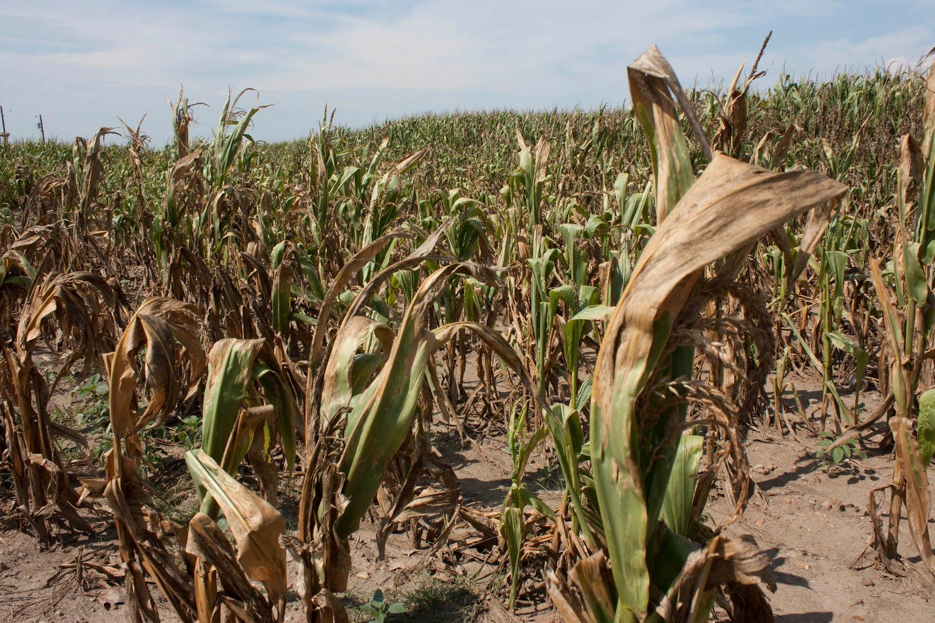

Figure 1.1 Poor yield due to under irrigation (krcu.org, 2013)

Most ofirrigation controllers that are locally available are ON/OFFtype and these cannot give optimal results inirrigation costs and crop yield.

Picture below shows a major problem of over irrigation experienced by traditional open loop irrigation systems. Water is wasted, crops become more vulnerable to water borne diseases, land fertility decreases as vital minerals are washed away with excess water and as a result poor yields are experienced.

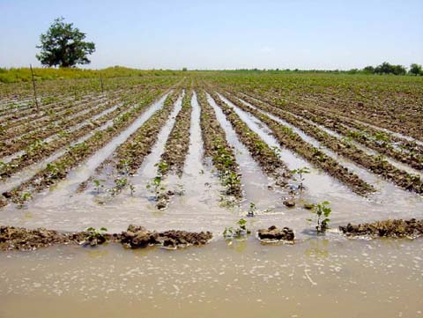

Figure 1.2 Picture showing over irrigated land (Columbia.edu, )

## Aim

To develop a smart irrigation system that is able to predict soil moisture contents to optimize irrigation schedules.

## Objectives

* Design an irrigation controller based on AVR micro-controller.
* Design SMS notification interface and web application for remote monitoring.
* Create a Neural Network Model to predict soil moisture contents.
* Size pipe work for a 266m2 prototype

## Scope

The scope of this project entails the design and implementation of a micro-controller based irrigationsystem driven by an artificial neural network to help on watering scheduling. Also the design of a notification interface which will be sending important data about the field to the farmer via SMS’s. An online dashboard is also going to be made for monitoring and controlling irrigation processes.

## Justification

The proposed project will help the country as a whole as it is a step towards minimizing water supply wastages through run-off and evaporation of excess water as a result of over irrigation. Every farmer in Zimbabwe has a goal of producing healthy crops and high yields and this can be achieved by introducing smart technologies which makes use of big data and learning strategies to assist in farming (Baiphethi and Jacobs, 2009). By doing so, Zimbabwe will gain back its fame in food security. This will reduce manual work of controlling the system, thereby reducing production costs, it is with no doubt that this technology will be of great help to farmers as it requires few operators in the field to monitor and control

Irrigation is one of the most reliable method of crops production.More land now is being under irrigation and there is a need for optimal use of water. With the great advancement in electronics, microcontrollers and microprocessors has been used together with various sensors to gather data and control physicalquantities like temperature, humidity, heat and light. Using these technologies automation of processes is greatly increasing. Irrigation systems in crop production can also be automated. The systems help in saving water and thus more land can bebrought under irrigation. Crops grown under controlled conditions tend to be healthier and thusgive more yields.

Every farmer wants to know what’s happening to the crops so that good decision can be made in time. This project makes it possible for remote monitoring of soil moisture, outdoor humidity and temperature, volume of water usage.

## Methodology

To achieve the project research techniques and tools are going to be used in the development phase. Secondary information to be used in the review will be developed from mainly journals,  
internet, hand books, eBooks and books. In building the controller, software api’s and hardware documentations are going to be reviewed.

Methods to be used:

* Data Gathering to obtain training data for soil moisture predictive model
* Concept selection through scoring of possible solutions.
* Developing an Artificial Neural Network in Matlab to create soil moisture content forecasts
* Developing cloud server controllers to interface backend services.
* Programming WeMos atmega2560 micro-controller for hardware controlling system.
* Building a prototype.

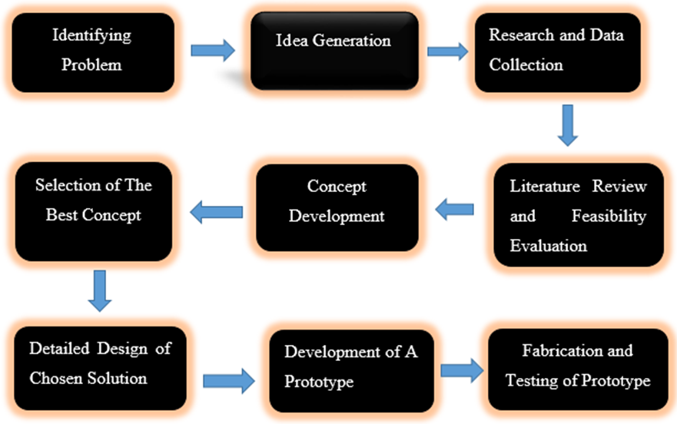

Figure 1.3 The Design and Development model.

## Timeline

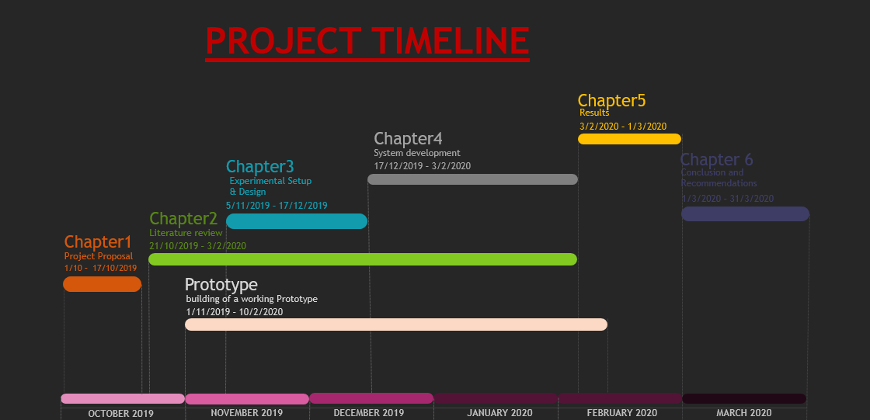

Figure 1.4 Project Timeline

Table 1.1 Scheduled timeline

|  |  |  |  |
| --- | --- | --- | --- |
| MILESTONE | START DATE | END DATE | NOTES |
| Chapter 1 | 1-10-2019 | 17-10-2019 | Project Proposal – Introduction to the project |
| Chapter 2 | 21-10-2019 | 3-2-2020 | Literature Review |
| Chapter 3 | 5-11-2019 | 17-12-2019 | Design and setup |
| Chapter 4 | 17-12-2019 | 3-2-2020 | System Development – detailed design of the concept and flow process |
| Chapter 5 | 3-2-2020 | 1-3-2020 | Project Results – Presentation of the system output |
| Chapter 6 | 1-3-2020 | 31-3-2020 | Conclusion and Recommendation |
| Prototype | 1-11-2019 | 10-2-2020 | Procure hardware components , build the controller and programming |

## Summary

The proposed project intends to use Artificial Intelligent techniques, which are growing in the field of agriculture and engineering as a whole. By gathering soil moisture values the system will be used to generate irrigation schedules and predict on the soil moisture values for the upcoming days and decisions can be made in time. In doing so, the system will encourage maximum efficiency of water usage and plant growth and healthy. With its capabilities, it will wrestle with problems related with under and over irrigation and major decisions will be made in time.

# CHAPTER TWO – LITERATURE REVIEW

## Introduction

## Types of Agricultural Water Use

There are two main ways that farmers and ranchers use agricultural water to cultivate crops

### Irrigation

Irrigation is the process of applying water to the crops artificially to fulfil their water requirements. Nutrients may also be applied to the crops through irrigation. The various sources of water for irrigation are wells, ponds, lakes, canals, tube-wells, and even dams. Irrigation offers moisture required for growth and development, germination, and other related functions.

Water moistens the soil and thus helps in penetration of roots even into the dry field. The frequency, rate, amount and time of irrigation are different for different crops and also vary according to the types of soil and seasons. For example, summer crops require a higher rate of water as compared to winter crops.

#### Types of Irrigation

There are different types of irrigation practised for improving crop yield. These types of irrigation systems are practised based on the different types of soils, climates, crops and resources. The main types of irrigation followed by farmers include:

##### Surface Irrigation

Water is applied and distributed over the soil surface by gravity. It is by far the most common form of irrigation throughout the world and has been practiced in many areas virtually unchanged for thousands of years. Surface irrigation is often referred to as flood irrigation, implying that the water distribution is uncontrolled and therefore, inherently inefficient. In reality, some of the irrigation practices grouped under this name involve a significant degree of management (for example surge irrigation). Surface irrigation comes in three major types; level basin, furrow and border strip.

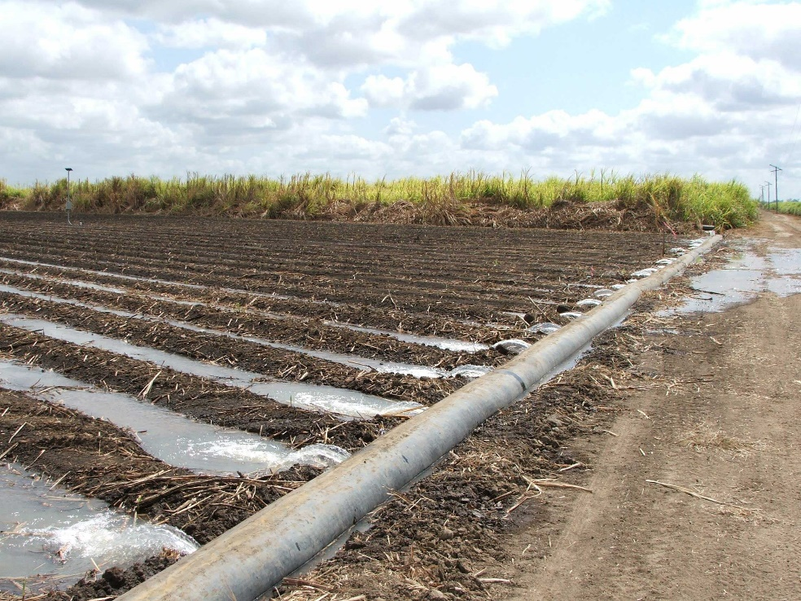

##### Localized irrigation

Localized irrigation is a method of applying water that results in wetting only a small area of the soil surface and sometimes only part of the root zone. Water is applied near the base of the plant so that the application is concentrated in the root zone. Water is generally applied at a low flow rate, in small amounts, and frequently. The application devices may be small tubes, orifices, nozzles, or perforated pipes. The water may either be applied above or below the soil surface. The main components of a localized irrigation system are the water supply (including flow and pressure regulators), the filtration system, main lines, sub-main lines, laterals, and distributors. Figure 5.27 shows some basic components of a localized irrigation system.

The primary advantages of localized irrigation systems are the high efficiency rates that can be achieved, sometimes as high as 90%. High efficiency may result in very significant water savings. Often a localized irrigation system will allow a farmer to irrigate twice the area possible with surface irrigation. Precise control of water and nutrient application often results in much higher yields and quality. Control of weeds and pests may be better as the entire soil surface is not wetted nor is the foliage. A localized irrigation system may allow the use of more saline water, and can be used effectively with low infiltration soils that cannot be sprinkler irrigated. Some disadvantages are the higher initial costs of the systems, salinity buildups, more limited root development, and higher technology requirements. Later savings may be offset by higher maintenance costs. There are low cost methods, however, for irrigating garden sized plots with localized irrigation.

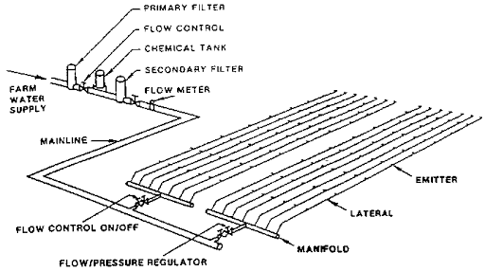

##### Sprinkler irrigation

Sprinkler irrigation is a method of applying irrigation water which is similar to natural rainfall. Water is distributed through a system of pipes usually by pumping. It is then sprayed into the air through sprinklers so that it breaks up into small water drops which fall to the ground. The pump supply system, sprinklers and operating conditions must be designed to enable a uniform application of water.

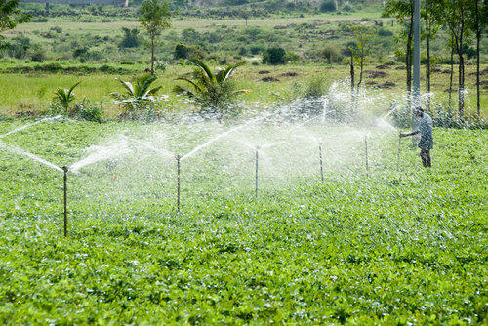

##### Centre Pivot Irrigation

The centre pivot (CP) is a low/medium pressure fully mechanized automated irrigation system of permanent assemble. The centre pivot system consists of one single sprayer or sprinkler pipeline of relatively large diameter, composed of high tensile galvanized light steel or aluminium pipes supported above ground by towers move on wheels, long spans, steel trusses and/or cables (Figure 10.1). One end of the line is connected to a pivot mechanism at the centre of the command area; the entire line rotates about the pivot. The application rate of the water emitters varies from lower values near the pivot to higher ones towards the outer end by the use of small and large nozzles along the line accordingly

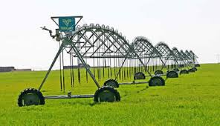

##### Sub-irrigation

It is a method of irrigation where water is delivered to the plant root zone. The excess may be collected for reuse. Sub irrigation is used in growing field crops such as tomatoes, peppers, and sugar cane in areas with high water tables such as Florida and in commercial greenhouse operations.

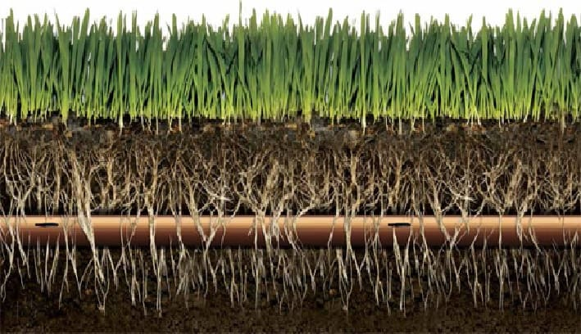

##### Manual Irrigation

Manual irrigation systems are very simple, labour intensive, but effective methods for making water available to crops. Manual irrigation systems are easy to handle and there is no need for technical equipment. It is important that they are constructed correctly to avoid water loss and crop shortfall. The systems allow for high self-help compatibility and have low initial capital costs.

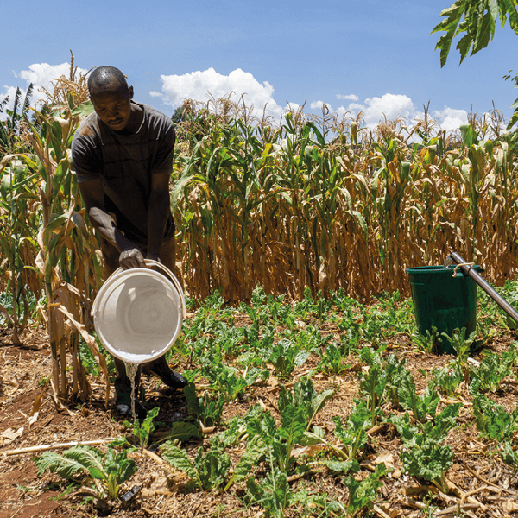

#### Methods of Irrigation

Irrigation can be carried out by two different methods:

* Traditional Methods
* Modern Methods

##### Traditional Methods of Irrigation

In this method, irrigation is done manually. Here, a farmer pulls out water from wells or canals by himself or using cattle and carries to farming fields. This method can vary in different regions. The main advantage of this method is that it is cheap. But its efficiency is poor because of the uneven distribution of water. Also, the chances of water loss are very high. Some examples of traditional system are pulley system, lever system, chain pump and dhekli. Among these, the pump system is the most common and used widely.

##### Modern Methods of Irrigation

The modern method compensates the disadvantages of traditional methods and thus helps in the proper way of water usage.

The modern method involves two systems:

* Sprinkler system
* Drip system

#### Irrigation Scheduling

#### Importance of Irrigation

* Agriculture is often greatly hampered due to irregular, insufficient or uncertain rain. Proper irrigation systems can secure uninterrupted agriculture.
* The productivity of irrigated land is more than the un-irrigated land. Crop yields everywhere in the developing world are consistently higher in irrigated areas than in rainfed areas1.
* Seeds cannot grow in dry soil as moisture is necessary for the germination of seeds. With the help of irrigation supply, the required moisture content of soil for the growth of seed can be ensured.
* Multiple cropping in a year is possible through irrigation. This will enhance production & productivity. In many areas of India, two or three crops in a year are cultivated with irrigation facilities.
* Through the irrigation, it is possible to supply the required amount of hydrogen & oxygen, which is important for the proper development of plant root.
* A plant can absorb mineral nutrients from the irrigated soil. Thus irrigation is essential for the general growth of the plant.
* Bringing more land under cultivation is possible through irrigation.
* Insufficient rain may also cause drought & famines. Irrigation can play a protective role during the period of drought & famines.
* Irrigation contributes to the economic growth and poverty reduction2. As income and employment are closely related to output and irrigation increases production, substantial increase in income is achieved in the countryside.

### Rain-fed Farming

Rain-fed farming is the natural application of water to the soil through direct rainfall. Relying on rainfall is less likely to result in contamination of food products but is open to water shortages when rainfall is reduced. On the other hand, artificial applications of water increase the risk of contamination.

## Specific Plant Water Requirements

### Soil Moisture for Optimal Crop Growth

Soil moisture and its availability to support plant growth is a primary factor in farm productivity. Too little moisture can result in yield loss and plant death. Too much causes root disease and wasted water. Just as important, water is a delivery mechanism for any nutrients that are not tightly bound to the soil. Whether these nutrients are delivered to the field through the irrigation system or through other means, movement of water within the soil governs how they are delivered to the plant roots. Good water management is important within itself, but good water management also means good nutrient management. Precise control over the root zone environment, in terms of both water and nutrient content, leads to healthier crops and higher yields.

#### Water Holding Capacity

Water resides in the spaces between soil particles. The force of gravity constantly acts on water in the soil to move it downward and out of reach of plants. The counterbalancing force which keeps it from moving downward is surface tension, which causes the water to 'stick' to soil particles. The smaller the soil particles are, the more combined surface area they have, and the more they are able to hold onto water through its surface tension. Therefore, the ability of water to move through soil and be stored in soil depends heavily on soil type.

When water enters a soil with large sandy particles, only a small amount stays attached to the particles, and the remainder quickly drains downward. Sand has low 'water holding capacity.' Conversely, a volume of clay soil has huge numbers of small particles with large surface area. When water enters a clay soil, surface tension holds it tightly to the soil particles and only a small remainder drains downward. A soil with a high water holding capacity can store large amounts of water relative to its own volume after a rain event and, under the right conditions, this stored water can remain available for plants to use.

In a soil with very small particles, the same surface tension forces that allow for a large water holding capacity also make it difficult for plants to extract and use the water. Water does not move easily through a fine-particle soil and requires a large amount of energy for plants to extract and use it. The force a plant must exert on water to separate it from soil particles and move it into the root system is referred to as 'tension'. In most on-farm applications tension is measured in centibars (1/100 bar) as a negative pressure or vacuum (plants 'suck' the water out of the soil to use it).

The interaction between soil type, water holding capacity and water availability is illustrated in the Soil Texture Triangle shown in Figure 1.

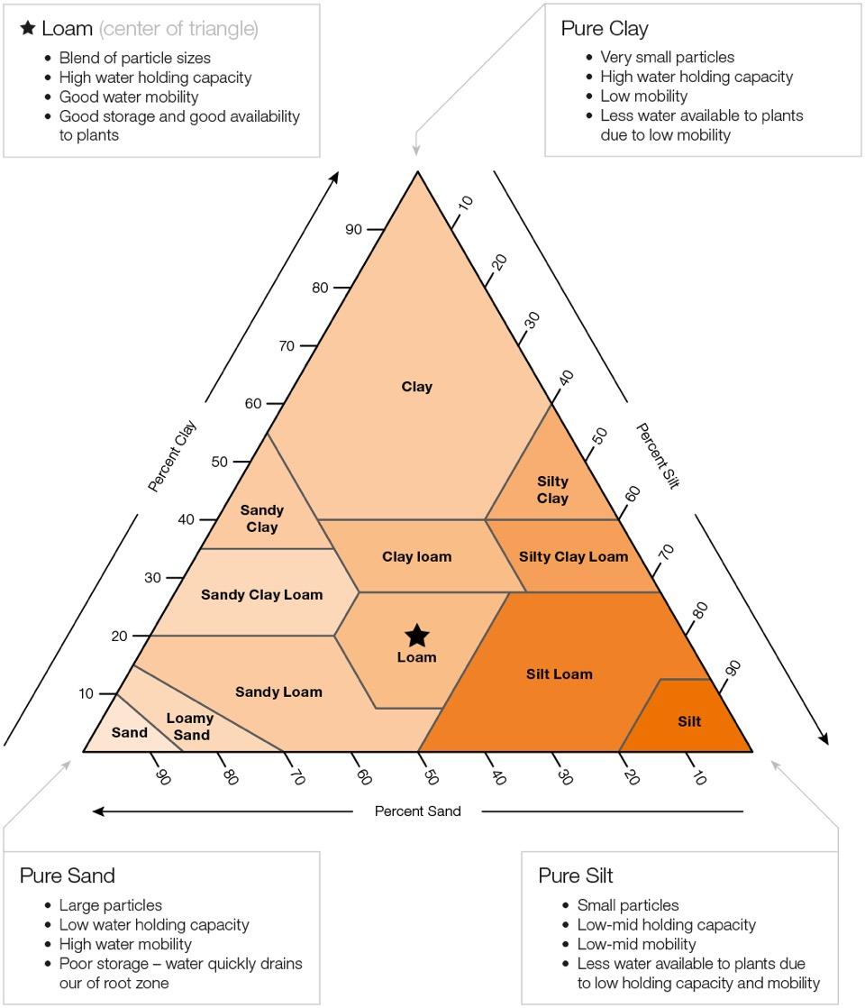

### Seasonal Crop Water Needs

|  |  |  |
| --- | --- | --- |
| **Crop** | **Crop water need (mm/total growing period)** | **Total growing period (days)** |
| Beans | 300 - 500 | 70-95 |
| Citrus | 900 - 1200 | 240-365 |
| Cotton | 700 - 1300 | 190-195 |
| Groundnut | 500 - 700 | 90-100 |
| Maize | 500 - 800 | 95-120 |
| Sorghum/millet | 450 - 650 | 120-130 |
| Soybean | 450 - 700 | 135-150 |
| Sunflower | 600 - 1000 | 125-130 |
|  |  |  |

There is a large variation of values not only between crops, but also within one crop type. In general, it can be assumed that the growing period for a certain crop is longer when the climate is cool and shorter when the climate is warm.

### Drought sensitivity

Crops differ in their response to moisture deficit. This characteristic is commonly termed "drought resistance" (Table 7 summarizes sensitivity to drought). When crop water requirements are not met, crops with a high drought sensitivity suffer greater reductions in yields than crops with a low sensitivity.

|  |  |  |
| --- | --- | --- |
| Group One | (low sensitivity) | Groundnuts |
| ¯ | Safflower |
| Group Two | ¯ | Sorghum |
| ¯ | Cotton |
| ¯ | Sunflower |
| Group Three | ¯ | Beans |
| Group Four | (high sensitivity) | Maize |

### Importance of Water to Plants

* Plants contain 90% water which gives turgidity and keeps them erect.
* Water is an essential part of protoplasm
* It regulates the temperature of the plant system
* It is essential to meet the transpiration requirements
* It serves as a medium for dissolving the nutrients present in the soil
* It is an important ingredient in photosynthesis

## Control Systems

A control system is a set of mechanical or electronic devices that regulates other devices or systems by way of control loops. Typically, control systems are computerized.

Control systems are a central part of industry and of automation. The types of control loops that regulate these processes include industrial control systems (ICS) such as supervisory control and data acquisition (SCADA) and distributed control systems (DCS).

Control systems are used to enhance production, efficiency and safety in many areas, including:

* Agriculture
* Chemical plants
* Quality control
* Power plant
* Environmental control
* Treatment plants
* Food and food processing
* Refining plants

### Types of Control Systems

#### Open Loop

It is a type of continuous control system in which the output has no influence or effect on the control action of the input signal. In other words, in an open-loop control system the output is neither measured nor “fed back” for comparison with the input. Therefore, an open-loop system is expected to faithfully follow its input command or set point regardless of the final result.

Also, an open-loop system has no knowledge of the output condition so cannot self-correct any errors it could make when the preset value drifts, even if this results in large deviations from the preset value.

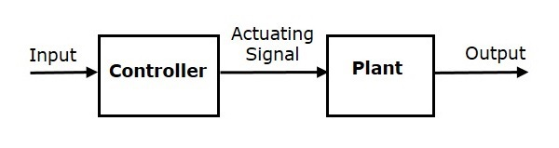

#### Closed Loop

A Closed-loop Control System, also known as a feedback control system is a control system which uses the concept of an open loop system as its forward path but has one or more feedback loops between its output and its input. The reference to “feedback”, simply means that some portion of the output is returned “back” to the input.

Closed-loop systems are designed to automatically achieve and maintain the desired output condition by comparing it with the actual condition. It does this by generating an error signal which is the difference between the output and the reference input. In other words, a “closed-loop system” is a fully automatic control system in which its control action being dependent on the output in some way.

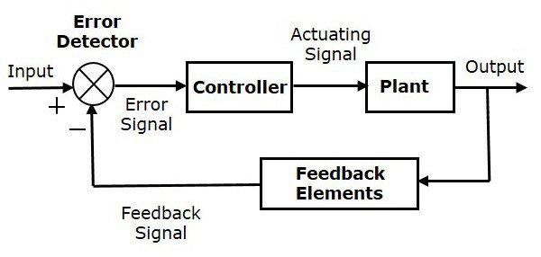

## Cloud Services

Cloud services provide many IT services traditionally hosted in-house, including provisioning an application/database server from the cloud, replacing in-house storage/backup with cloud storage and accessing software and applications directly from a web browser without prior installation.

Cloud services provide great flexibility in provisioning, duplicating and scaling resources to balance the requirements of users, hosted applications and solutions. Cloud services are built, operated and managed by a cloud service provider, which works to ensure end-to-end availability, reliability and security of the cloud.

### Types of Cloud Services:

#### Software as a service (SaaS)

Used for web-based applications. SaaS is a method for delivering software applications over the Internet where cloud providers host and manage the software applications making it easier to have the same application on all of your devices at once by accessing it in the cloud.

#### Infrastructure as a service (IaaS)

Used for Internet-based access to storage and computing power. The most basic category of cloud computing types, IaaS lets you rent IT infrastructure - servers and virtual machines, storage, networks, and operating systems - from a cloud provider on a pay-as-you-go basis.

#### Platform as a service (PaaS)

Gives developers the tools to build and host web applications. PaaS is designed to give users access to the components they require to quickly develop and operate web or mobile applications over the Internet, without worrying about setting up or managing the underlying infrastructure of servers, storage, networks, and databases.

### Cloud Services Providers

* Amazon Web Service (AWS)
* Heroku
* Microsoft Azure
* Google Cloud Platform
* IBM Cloud Services
* Adobe Creative Cloud
* Oracle Cloud
* SAP
* Dropbox

## Data Forecasting

## Hardware

### Micro-controllers and Processors

A microcontroller is a single on chip computer which includes number of peripherals like RAM, EEPROM, Timers etc., required to perform some predefined task. There are different microcontroller families including: 8051, PIC (Programmable Interface Controller) and AVR. Microcontrollers are used in digital applications as control units. Some microcontrollers come with their in-build circuits like Analog to digital convertors or digital to analog convertors.19 Microcontrollers are mostly programmed using assembly language but in recent years high level languages like C, C++ PASCAL and java have been used. High level programming of microcontrollers brings the advantage of not having a different program for each microcontroller

manufacturer. High level programming is also neat, easy to document and maintain and user

friendly.

#### Types of Micro-controllers

##### 8051

These are among the earlier microcontrollers to be fabricated. Due to superiority in technology in the newer versions, very few companies still fabricate 8051. Earlier types of 8051 have 12 clocks per instruction whereas the newer versions have 6 clocks per instruction. 8051 microcontroller does not have an in built memory bus and ADC. First 8051 microcontroller to be fabricated with

Harvard architecture was done in 1980 by Intel.

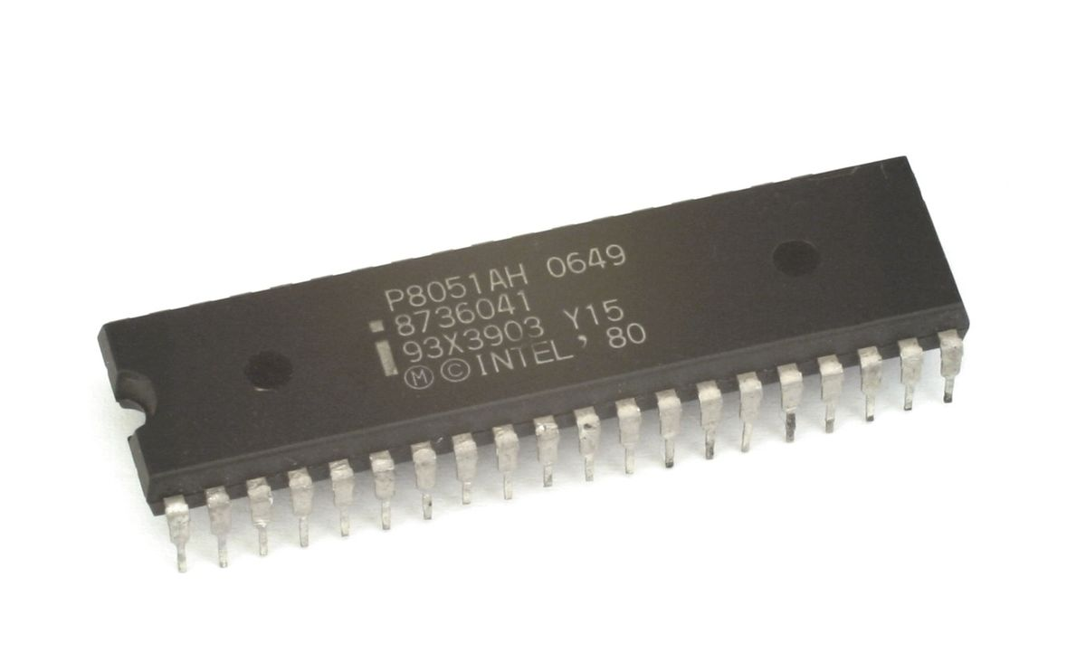

##### Programmable Interface Controller (PIC)

Programmable Interface Controllers are commonly referred to as PIC. PICs are slightly older than 8051 microcontrollers. PICs are preferred to 8051 because of their small low pin count devices. PICs perform better and are affordable than 8051. [3] The Microchip technology fabricated the single chip microcontroller PIC with Harvard architecture. The only major downside of PIC is its programming part is very tedious. PICs are hence not recommended for beginners.

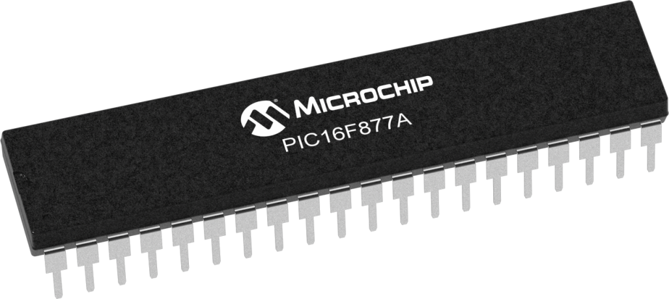

##### AVR

In 1996, Atmel fabricated this single chip microcontroller with a modified Harvard Architecture. This chip is loaded with C- compiler and a free IDE. Like PIC, AVR microcontrollers are difficult for the beginners to work with. AVR microcontroller has on-chip boot-loader thus AVR can be programmed easily without any external programmer. [3] AVR controllers has number of I/O ports, timers/counters, interrupts, A/D converters, USART, I2C interfaces, PWM channels, on-chip analog comparators.

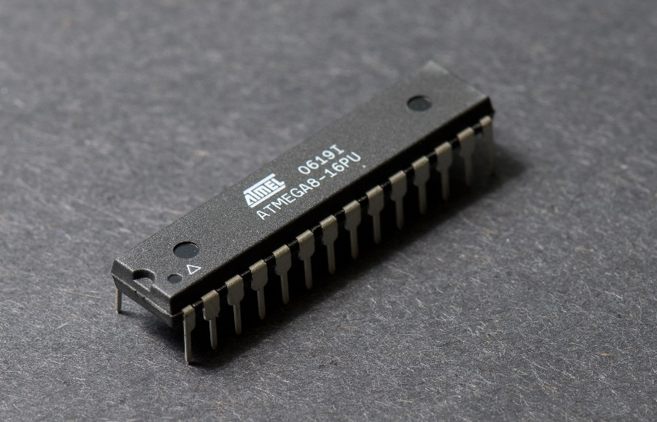

#### Arduino Boards

Arduino is an open-source electronics design platform. The Arduino board is specially designed for programming and prototyping with Atmel microcontrollers. [5] An arduino interacts with physical world via sensors. Using arduino; electric equipments can be designed to respond to change in physical elements like temperature, humidity, heat or even light. [5] This is the automation process. For example, reading a humidity sensor and turning on and off of an automatic irrigation system. There several types of arduino boards. The open-source Arduino environment allows one to write code and load it onto the Arduino board's memory. The development environment is written in Java and based on Processing, AVR-GCC, and other open source software. [5] The Arduino programming language is an implementation of Wiring, a similar physical computing platform, which is based on the Processing multimedia programming environment. The arduino software is published as open source tools, available for extension by experienced programmers. The language can be expanded through C++ libraries, and people wanting to understand the technical details can make the leap from Arduino to the AVR C programming language on which it's based. Similarly, AVR-C code can be added directly into the Arduino programs if one so wishes.

##### Arduino Uno

This is the most common arduino type. This arduino type uses ATmega328 AVR microcontroller.

Features of the Arduino UNO:

* Microcontroller: ATmega328
* Operating Voltage: 5V
* Input Voltage (recommended): 7-12V
* Input Voltage (limits): 6-20V
* Digital I/O Pins: 14 (of which 6 provide PWM output)
* Analog Input Pins: 6
* DC Current per I/O Pin: 40 mA
* DC Current for 3.3V Pin: 50 mA
* Flash Memory: 32 KB of which 0.5 KB used by bootloader
* SRAM: 2 KB (ATmega328)
* EEPROM: 1 KB (ATmega328)
* Clock Speed: 16 MHz

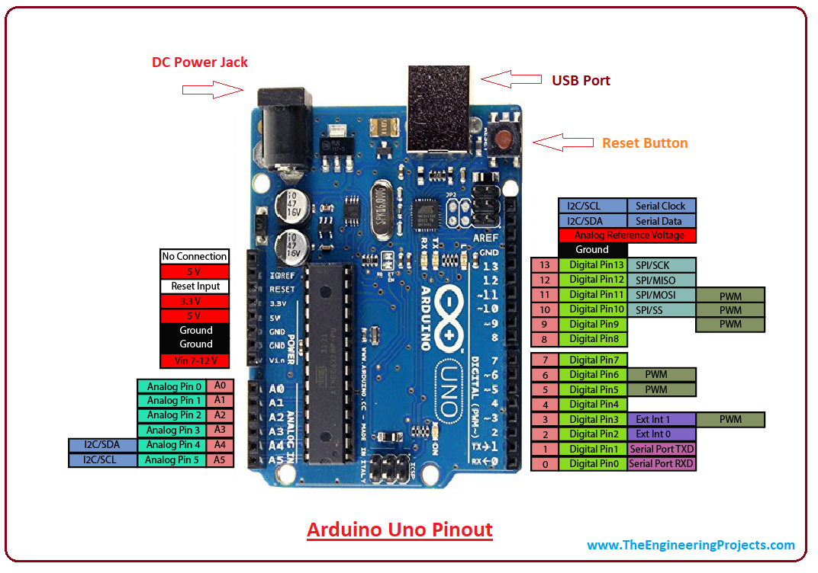

##### Arduino Mega 2560

This is regarded as an advancement of Arduino uno. It has more memory than arduino uno. It has

a total of 54 input pins of which 16 are analog inputs. It has a larger PCB board than arduino.

Overall it is more powerful than arduino uno. This arduino board is based on ATmega2560

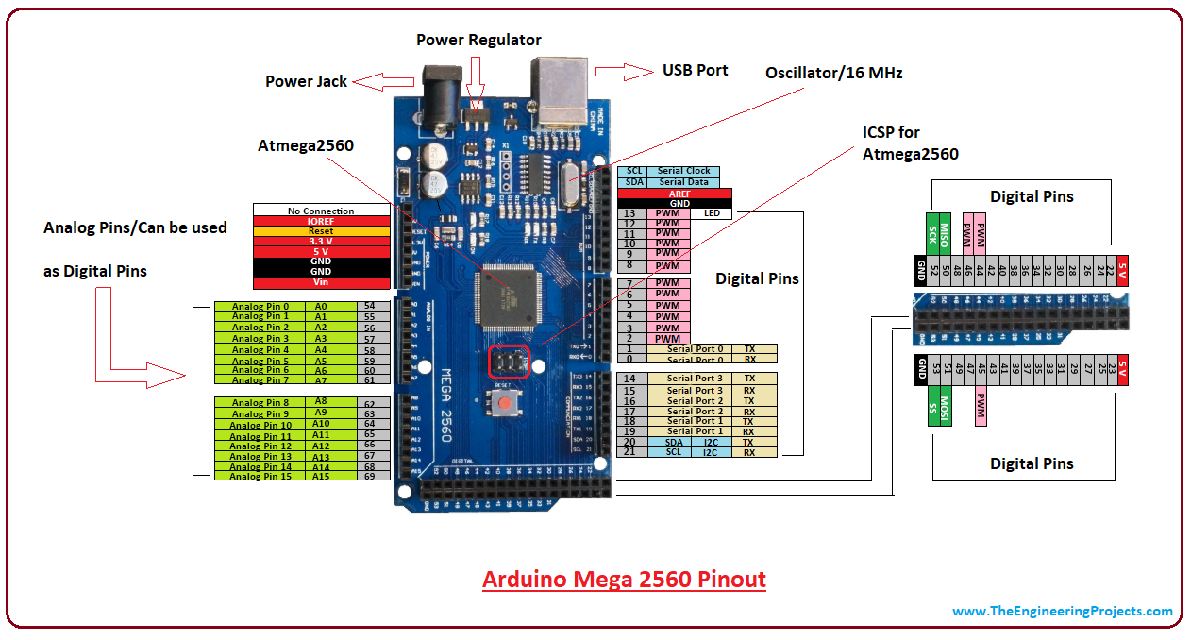

##### Arduino LilyPad

This arduino board is designed for wearable applications. It is usually sewn on fabric. This board

requires the use of a special FTDI-USB TTL serial programming cable. Arduino LilyPad is used

to design "smart" wearable.

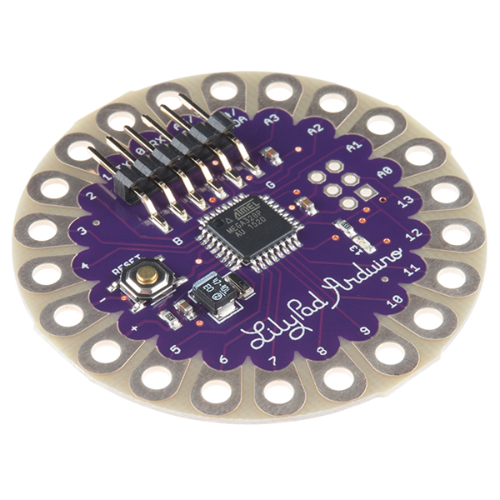

### Communication

Electronic communication is the meaningful exchange of information at a distance by technological means, particularly through electrical signals or electromagnetic waves.

#### Gsm Sim800L

SIM800L GSM/GPRS module is a miniature GSM modem. The module can accomplish almost anything a normal cell phone can SMS text messages, Make or receive phone calls, connecting to internet through GPRS and TCP/IP. The module supports quad-band GSM/GPRS network, meaning it works pretty much anywhere in the world.

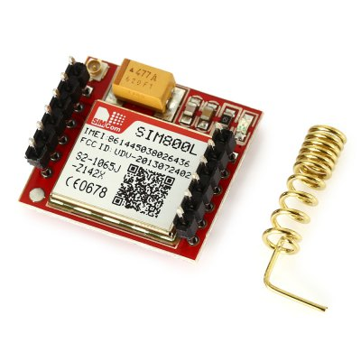

##### Hardware Overview

All the necessary data pins of SIM800L GSM chip are broken out to a 0.1″ pitch headers. This includes pins required for communication with a microcontroller over UART. The module supports baud rate from 1200bps to 115200bps with Auto-Baud detection

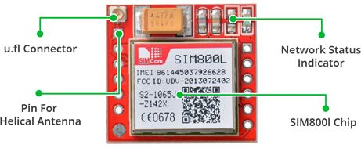

This module measures 1 inch² but packs a lot of features into its little frame. Some of them are listed below:

* Supports Quad-band: GSM850, EGSM900, DCS1800 and PCS1900
* Connect onto any global GSM network with any 2G SIM
* Make and receive voice calls using an external 8Ω speaker & electret microphone
* Send and receive SMS messages
* Send and receive GPRS data (TCP/IP, HTTP, etc.)
* Scan and receive FM radio broadcasts
* Transmit Power:
  + Class 4 (2W) for GSM850
  + Class 1 (1W) for DCS1800
* Serial-based AT Command Set
* FL connectors for cell antennae
* Accepts Micro SIM Card

#### Esp8266

he ESP8266 is a low-cost Wi-Fi microchip, with a full TCP/IP stack and microcontroller capability, produced by Espressif Systems

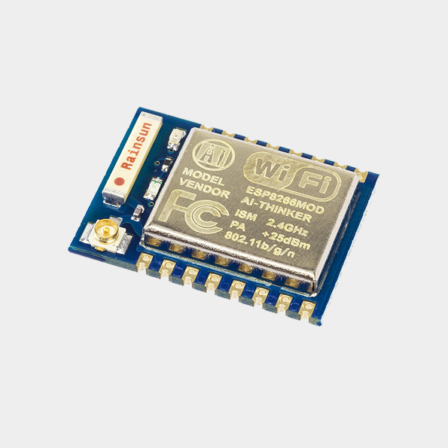

##### Features

* Processor: L106 32-bit RISC microprocessor
* Memory:
  + 32 KiB instruction RAM
  + 32 KiB instruction cache RAM
  + 80 KiB user-data RAM
  + 16 KiB ETS system-data RAM
* IEEE 802.11 b/g/n Wi-Fi
* 16 GPIO pins
* SPI
* I²C (software implementation)
* I²S interfaces with DMA (sharing pins with GPIO)
* UART on dedicated pins, plus a transmit-only UART can be enabled on GPIO2
* 10-bit ADC

### Data Storage

The micro- SD Card Module is a simple solution for transferring data to and from a standard SD card. The pin out is directly compatible with microcontrollers and processors. It allows you to add mass storage and data logging to any project.

This module has SPI interface which is compatible with any sd card and it use 5V or 3.3V power supply which is compatible with Arduino UNO/Mega.

SD module has various applications such as data logger, audio, video, graphics. This module will greatly expand the capability an Arduino can do with their poor limited memory.

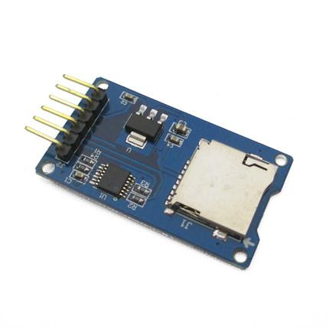

#### Specifications

* Working Voltage: 5V/3.3V
* Size:20x28mm
* Interface: SPI
* Compatible: MicroSD

### Sensors

A sensor is a device that detects and measures a physical quantity from the environment and

converts it into an electronic signal. The physical quantity could be moisture, temperature,

motion, light or any other physical phenomenon. Examples of sensors include: oxygen sensors,

temperature sensors, infra red sensors, humidly sensors, soil moisture sensors and motion

detection sensors. The output of the sensors is usually charge, current or voltage. Of interest in

this paper is the soil moisture sensor.

#### Soil Moisture Sensors

A soil moisture sensor is a device that measures the volumetric water content (VWC) of soil.

Mathematically VWC, θ, is given as follows

$$θ=\frac{V_{W}}{V_{T}}$$

Where: VW is the water volume and VT is the total volume (soil volume + water volume).

Soil moisture sensors are classified according to how they measure the soil moisture content.

##### Types of soil moisture sensors

###### Capacitance sensors

Capacitance sensors use frequency domain reflectometry (FDR). Frequency domain reflectometry is the measure of signal reflections through a medium across frequency. Capacitance sensors contain two electrodes which are separated by a dielectric material. The soil becomes the dielectric component after the electrodes are inserted into the soil; it could even be inserted into the access tube in the soil to achieve the same results. A high oscillating frequency is thereafter applied to the electrodes to induce a resonant frequency. The magnitude of the resonant frequency is dependent on the dielectric constant of the soil which in turns depends on or can change to the soil’s moisture content. The change of the frequency as a result of the soil’s moisture content is converted into the measurement of the soil moisture.

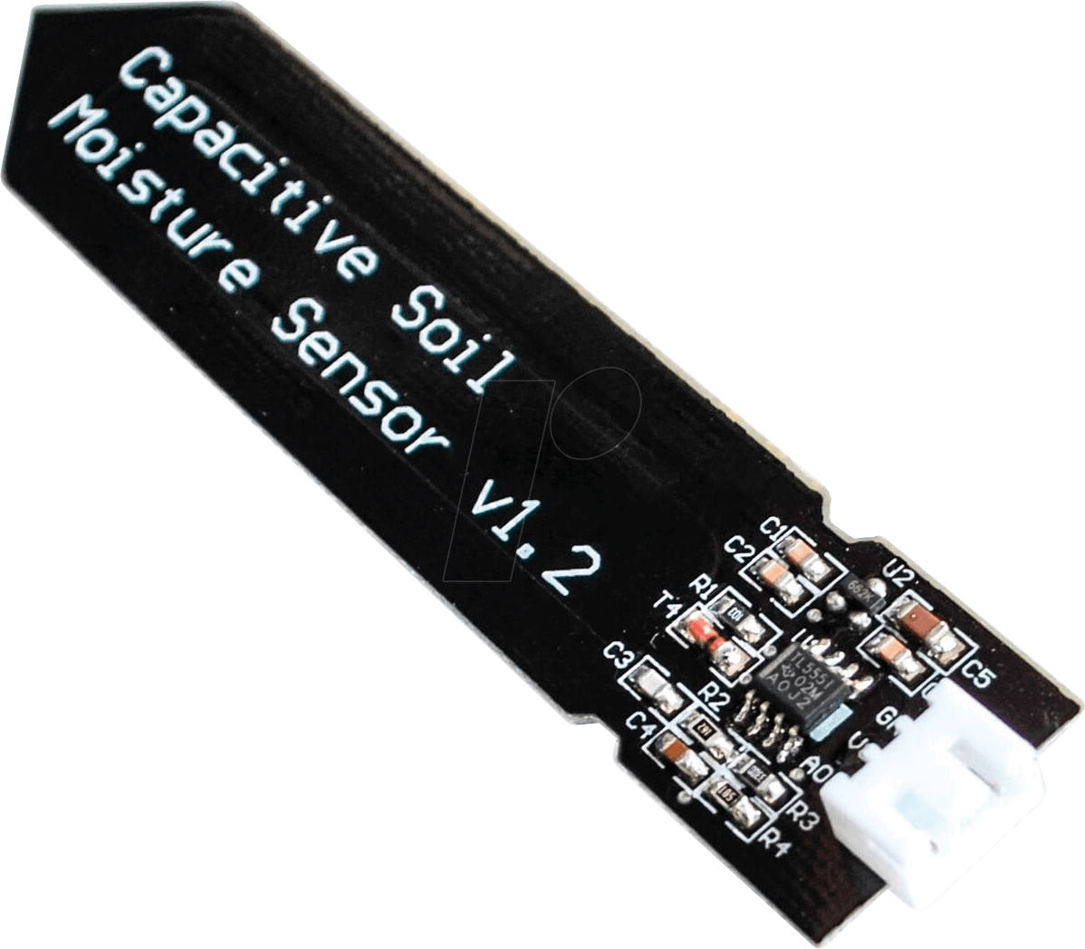

###### Time Domain Reflectometry (TDR) sensors

Time Domain Reflectometry uses the principle of waveguides. The actual content of water in the soil is measured under this technology and not the water potential. The TDR device sends signals to the rods inserted in the soil. The time required for an electromagnetic signal to travel10 along the wave guide is measured. The rate at which the send signal returns is used to measure the water content in the soil. The return rate is dependent on the dielectric properties of the soil. The signal takes longer time in moisture soils and shorter time in dry soil. This pulse signal is then converted into soil moisture measurement. TDR sensors give accurate readings faster and require very little maintenance. The major disadvantage of TDR sensors is that they require different calibrations depending on different soil types

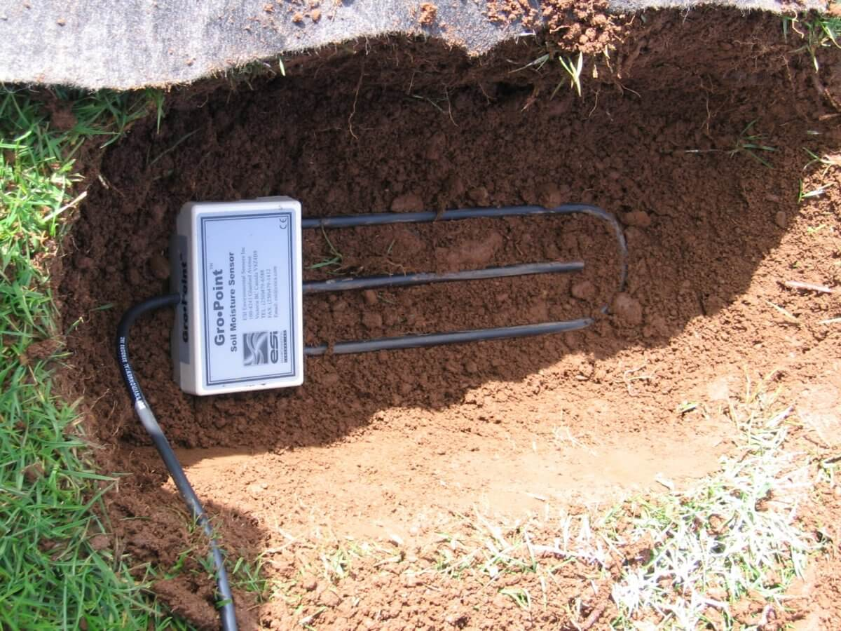

###### Electrical resistance blocks Sensors

These sensors are made up of two electrodes made from a porous substance like sand ceramic

mixture or gypsum. The two electrodes are imbedded in the soil during installation. [4] Moisture

is allowed to move freely in and out of the sensors electrodes as the soil becomes moist or dries

up. The resistance of the electrodes to the flow current is correlated with moisture content. To

measure this resistance the electrodes are biased (energized) with a dc voltage and the current

flowing through them measured. Applying Ohm’s law

$R= \frac{V}{I}$

Where: R is resistance (Unknown) (Ω)

V is biasing voltage (3.3V to 5.0V)

I is the current flowing through the electrodes (Amps)

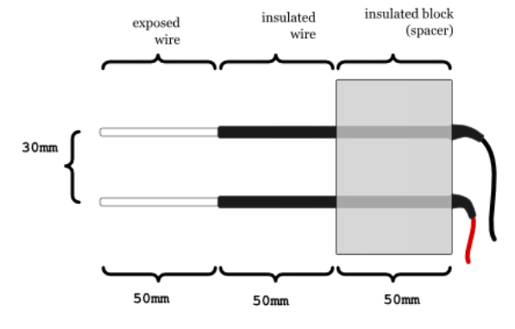

#### Temperature Sensors

A temperature sensor is a device, usually an RTD (resistance temperature detector) or a thermocouple, that collects the data about temperature from a particular source and converts the data into understandable form for a device or an observer. Temperature sensors are used in many applications like HV and AC system environmental controls, food processing units, medical devices, chemical handling and automotive under the hood monitoring and controlling systems

The most common type of temperature sensor is a thermometer, which is used to measure temperature of solids, liquids and gases. It is also a common type of temperature sensor mostly used for non-scientific purposes because it is not so accurate.

##### Types of Temperature Sensors

###### Thermocouples

Thermocouple sensor is the most commonly used temperature sensor and it is abbreviated as TC. This sensor is extremely rugged, low-cost, self-powered and can be used for long distance. There are many types of temperature sensors that have a wide range of applications.

A thermocouple is a voltage device that indicates temperature by measuring a change in the voltage. It consists of two different metals: opened and closed. These metals work on the principle of thermo-electric effect. When two dissimilar metals produce a voltage, then a thermal difference exists between the two metals. When the temperature goes up, the output voltage of the thermocouple also increases.

This thermocouple sensor is usually sealed inside a ceramic shield or a metal that protects it from different environments. Some common types of thermocouples include K, J, T, R, E, S, N, and B. The most common type of thermocouples is J, T and K type thermocouples, which are available in pre-made forms.

The most important property of the thermocouple is nonlinearity – the output voltage of the thermocouple is not linear with respect to temperature. Thus, to convert an output voltage to a temperature, it requires mathematical linearization.

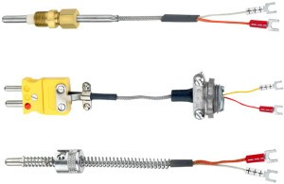

###### Resistor Temperature Detector (RTD)

RTD sensor is one of the most accurate sensors. In a resistor temperature detector, the resistance is proportional to the temperature. This sensor is made from platinum, nickel, and copper metals. It has a wide range of temperature measurement capabilities as it can be used to measure temperature in the range between -270oC to +850oC. RTD requires an external current source to function properly. However, the current produces heat in a resistive element causing an error in the temperature measurements.

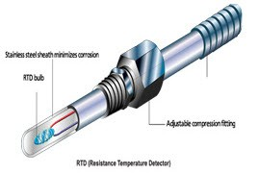

###### Thermistors

Another type of sensor is a thermistor temperature sensor, which is relatively inexpensive, adaptable, and easy to use. It changes its resistance when the temperature changes like RTD sensor. Thermistors are made from manganese and oxides of nickel, which make them susceptible to damages. So, these materials are called ceramic materials. This thermistor offers higher sensitivity than the resistor temperature detectors. Most of the thermistors have a negative temperature coefficient. It means, when the temperature increases the resistance decreases.

###### Thermometers

A thermometer is a device used to measure the temperature of solids, liquids, or gases. The name thermometer is a combination of two words: thermo – means heat, and meter means to measure. Thermometer contains a liquid, which is mercury or alcohol in its glass tube. The volume of the thermometer is linearly proportional to the temperature – when the temperature increases, the volume of the thermometer also increases.

When the liquid is heated it expands inside the narrow tube of the thermometer. This thermometer has a calibrated scale to indicate the temperature. The thermometer has numbers marked alongside the glass tube to indicate the temperature when the line of mercury is at that point. The temperature can be recorded in these scales: Fahrenheit, Kelvin or Celsius. Therefore, it is always desirable to note for which scale the thermometer is calibrated.

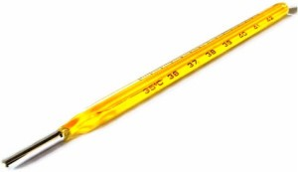

###### Semiconductor Sensors

Semiconductor sensors are the devices that come in the form of ICs. Popularly, these sensors are known as an IC temperature sensor. They are classified into different types: Current output temperature sensor, Voltage output temperature sensor, Resistance output silicon temperature sensor, Diode temperature sensors and Digital output temperature sensor. Present semiconductor temperature sensors offer high linearity and high accuracy over an operating range of about 55°C to +150°C. However, AD590 and LM35 temperature sensors are the most popular temperature sensors.

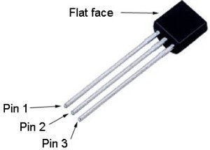

###### IR sensor

IR sensor is an electronic instrument which is used to sense certain characteristics of its surroundings by either emitting or detecting IR radiation. These sensors are non-contacting sensors. For example, if you hold an IR sensor in front of your desk without establishing any contact, the sensor detects the temperature of the desk based on the merit of its radiation. These sensors are classified into two types such as thermal infrared sensors and quantum infrared sensors.

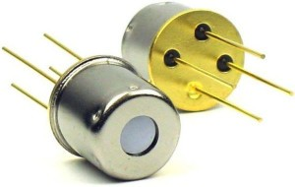

#### Humidity Sensors

A humidity sensor (or hygrometer) senses, measures and reports both moisture and air temperature. The ratio of moisture in the air to the highest amount of moisture at a particular air temperature is called relative humidity. Humidity sensors work by detecting changes that alter electrical currents or temperature in the air.

##### Types of Humidity Sensors

###### Capacitive

A capacitive humidity sensor measures relative humidity by placing a thin strip of metal oxide between two electrodes. The metal oxide’s electrical capacity changes with the atmosphere’s relative humidity. Weather, commercial and industries are the major application areas.

The capacitive type sensors are linear and can measure relative humidity from 0% to 100%. The catch here is a complex circuit and regular calibration. However, for designers this a lesser hassle over precise measurement and hence these dominate atmospheric and process measurements. These are the only types of full-range relative humidity measuring devices down to 0% relative humidity. This low-temperature effect often leads to them being used over wide temperature ranges without active temperature compensation.

###### Resistive

Resistive humidity sensors utilize ions in salts to measure the electrical impedance of atoms. As humidity changes, so do the resistance of the electrodes on either side of the salt medium.

###### Thermal

Two thermal sensors conduct electricity based upon the humidity of the surrounding air. One sensor is encased in dry nitrogen while the other measures ambient air. The difference between the two measures the humidity.

##### DHT 22 Sensor

The DHT-22 (also named as AM2302) is a digital-output relative humidity and temperature sensor. It uses a capacitive humidity sensor and a thermistor to measure the surrounding air, and gives out a digital signal on the data pin.

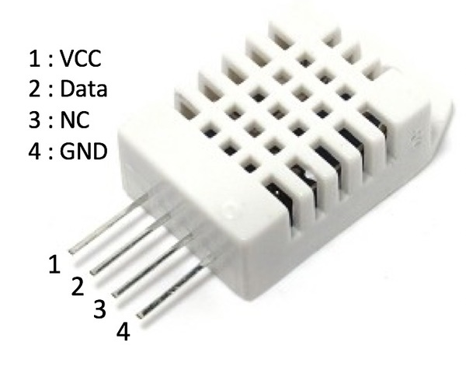

#### Sensor Selection

When deciding on which sensor to use the following factors should be put into consideration:

* **Price**: This is the most important parameter when selecting any component. The price of the sensor will ultimately affect the price of the whole system as this is one of the major system modules. Sensor with the most competitive price should be chosen.
* **Power**: In any electrical system power efficiency is critical. Moisture sensor will low power consumption should be selected. Sensors which can be battery powered can be used in areas without electricity connection.
* **Technology**: Technology used to design sensor dictate the sensitivity, cost and durability of the sensors. Most low-cost sensors have poor sensitivity, rust and corrode over time. Resistive or conductive sensors which are affected by soli salinity thus have a short life.
* **Shape**: Long and slender sensors can be used in many applications than bulky ones.
* **Durability**: Soil moisture sensor which are not affected by soil salinity, corrode or rust should be selected. Soil moisture sensor probes that measure conductivity or resistance should be avoided, since they will wear out over time.
* **Accuracy and Linearity**: A quality soil moisture sensor probe should give an output which is proportional to water content over the full output range. In addition, the soil moisture sensor probe should have a good output range to reduce sensitivity to noise.
* **Voltage Range**: Choose a sensor that has a big supply voltage range. Powering a sensor with the wrong voltage will damage the sensor or give inaccurate results.

### Displays

Liquid Crystal Display (LCD) screen is an electronic display module. An LCD has a wide range  
of applications in electronics. The most basic and commonly used LCD in circuits is the 20 x 4  
display. LCDs are commonly preferred in display because they are cheap, easy to program  
and can display a wide range of characters and animations.  
A 20 x 4 LCD have two display lines each capable of displaying 20 characters. This LCD has  
Command and Data registers. The command registers stores command instructions given to the  
LCD while the Data register stores the data to be displayed by the LCD.

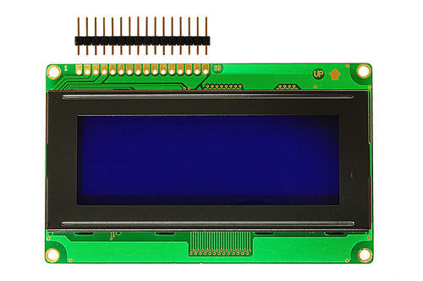

When using 8-bit configuration all 8 data pins (DB0-DB7) are used while only 4 data pins (DB4-

DB7) are used in a 4-bit configuration.

|  |  |  |
| --- | --- | --- |
| **Pin number** | **Function** | **symbol** |
| 1 | Ground (0V) | VSS |
| 2 | Supply voltage (5V) | VDD |
| 3 | Contrast adjustment; through a variable resistor(potentiometer) | V0 |
| 4 | Selects command register when low; and data register when high | RS |
| 5 | Low to write to the register; High to read from the register | RW |
| 6 | Sends data to data pins when a high to low pulse is given | E |
| 7 | 8-bit data pins | D0 |
| 8 | 8-bit data pins | D1 |
| 9 | 8-bit data pins | D2 |
| 10 | 8-bit data pins | D3 |
| 11 | 8-bit data pins | D4 |
| 12 | 8-bit data pins | D5 |
| 13 | 8-bit data pins | D6 |
| 14 | 8-bit data pins | D7 |
| 15 | Backlight VCC (5V) | A |
| 16 | Backlight Ground (0V) | K |

# CHAPTER THREE: METHODOLOGY AND DESIGN CONCEPTION

## Introduction

In this chapter the author focuses on the generation of concepts for smart irrigation scheduling. By combining ideas, potential solutions of the system are developed without getting in technical detail, although important factors will be addressed. The concepts are then evaluated using a number of tools so that their strengths and weaknesses are distinguished.

## Concept Generation

This section focuses on the description of the system's components and their configuration in the system. Using concept scoring, the best solution is selected based on different design criteria.

### Determination of Customer Requirements

Customer requirement determination is the first step in the product creation process and is one of the most significant as it contributes to the production of a consumer-based product. The consumer requirements were obtained from interviews with various horticulture farmers in Harare.

Consumer requirements:

* Efficiency of the irrigation system
* Ease of Use
* Taking other parameters into consideration which affect soil moisture content.
* Ease of Maintenance
* System Durability
* Remote Monitoring and Control
* Uniform monitoring of the field
* Precision and Accuracy in Responsiveness

## Generation of Concepts

### Concept A

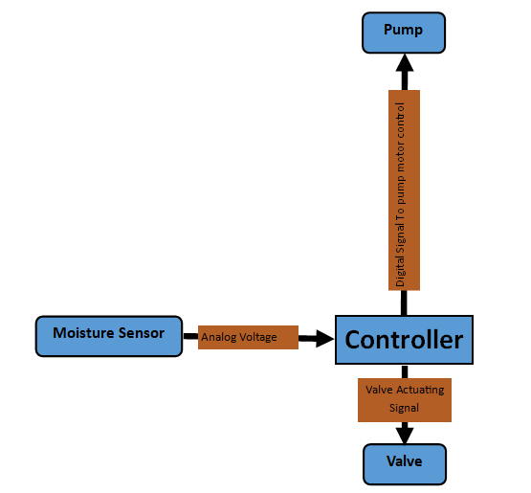

#### Principle of operation

Soil Moisture sensor in the field sends analog signal to a controller depending on the water content in the soil. The controller processes the signal and depending on the set-points set on the controller a decision is made to irrigate or not. When the sensor input is below the setpoint a high signal is sent to the valve actuator to open the valve and also to the motor control contactor to start the pump motor. When the sensor input is above the setpoint, the controller sends low signals to the motor control contactor and valve actuator. The type of valve used is normally closed, only opens when the actuator receives a high signal from the controller. This concept uses on-demand irrigation scheduling, water is only delivered to the field when the moisture falls below the setpoint.

##### Flow-Chart

Read Sensor Value

Is Moisture below setpoint

Send High Signal to Motor and Valve Actuator

No

YES

#### Advantages

* Easy to setup
* Easy to maintain as it is less complex

#### Disadvantages

* Not resource efficient,
* Doesn’t take into consideration other parameters that affect soil moisture.
* It doesn’t have a notification interface
* Operators cannot remotely monitor

### Concept B

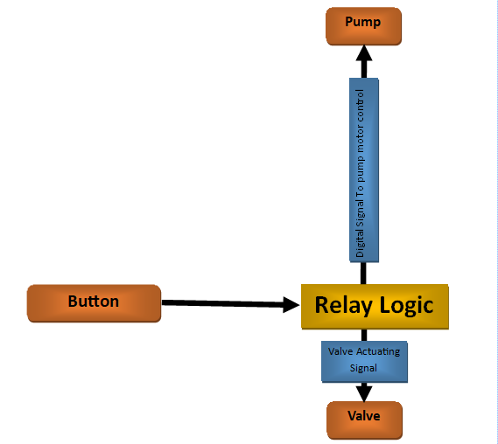

#### Principle of operation

This concept uses relay logic. When you press the start button the field valve will be opened and pump will be started after sending high signals from the relay logic circuit to all control devices in the field.

##### Flow-Chart

Is Button Pressed

Read button State

Send High signal to Motor Control and Valve actuator

YES

NOO

#### Advantages

* Easy to setup
* Easy to maintain as it is less complex
* Cheap to setup

#### Disadvantages

* Not resource efficient,
* Doesn’t take soil moisture into consideration.
* It doesn’t have a notification interface
* Operators cannot remotely monitor
* Rigid not flexible
* Operator has to constantly monitor the irrigation process

### Concept C

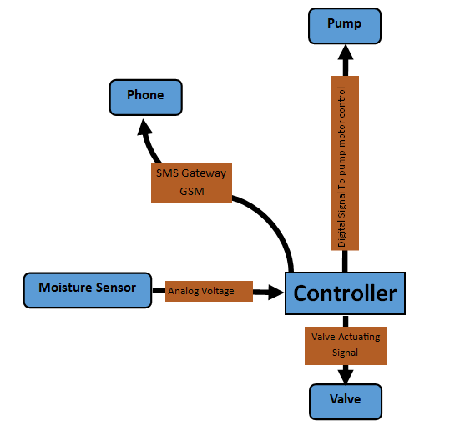

#### Principle of operation

In this concept a controller acquires soil moisture values form the field sensor and a Propotional, Integral and Derivative algorithm set in the controller maintains the moisture content in the field by controlling the valve and pump to irrigate the field. It features a notification interface which allows the operator to remotely monitor the field.

##### Flow-Chart

Read Sensor Value

Is Moisture below setpoint

Send High Signal to Motor and Valve Actuator

No

YES

Is uptime – flag >30minutes

Send Moisture Value and logs to Operator

Clear logs  
flag = uptime

YES

No

#### Advantages

* Allows remote monitoring
* Easy to setup
* Easy to maintain as it is less complex

#### Disadvantages

* Not resource efficient,
* Doesn’t take into consideration other parameters that affect soil moisture.
* It doesn’t have a notification interface
* Operators cannot remotely monitor

### Concept E

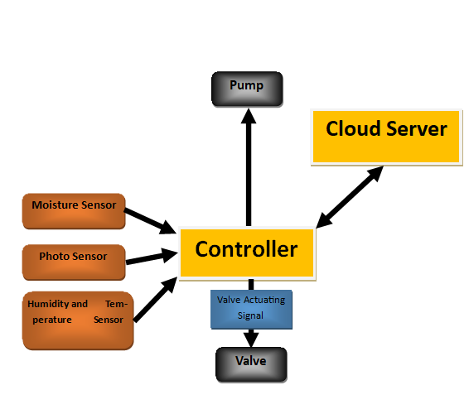

#### Principle of operation

Controller acquires soil moisture, temperature, humidity and sunshine intensity from field sensor. Pre-processing of the signal is done on the controller and stored to a local SD-card. The data is sent to a cloud server on the internet for post processing. On the cloud server analysis of the data is done and a forecast of soil moisture for the coming days is done, a response is sent back to the controller with the specific moisture content that should be maintained. If there is need to irrigate the controller send high signals to motor pump control and valve actuator.

#### Advantages

* Takes in almost all aspects that affect soil moisture.
* Uses optimization prediction algorithms which predicts the right amount of water content which should be maintained
* Favors maximum yield as crops get the optimum water content.
* Saves on water usage as forecasting is incorporated.

#### Disadvantages

* Complex
* Needs a high skilled technician to maintain
* Lacks user interfaces.
* A break down on internet connection means the online server won’t be available to serve irrigation plan.
* Existence of a second server means the reliability of the system is compromised from a maintenance standpoint.
* Vulnerable to cyber-attacks.

## Concept Selection

In this section concept screening and concept scoring is going to be done to evaluate and select the best concept amongst the four concepts generated.

### Concept Screening

Basing on a list of parameters that define the selection criteria and making use of the concept as the reference concept. The table below shows the selection criteria and the comparisons

#### Key

+ : is better than

- : indicates is worse than

0 : indicates is same as

|  |  |  |  |  |  |
| --- | --- | --- | --- | --- | --- |
| **SELECTION CRITERIA** | **CONCEPT** | | | | |
| **ONE** | **TWO** | **THREE** | **FOUR** | **Reference** |
| Ease of Use |  |  |  |  | 0 |
| Ease of Maintenance |  |  |  |  | 0 |
| Remote Monitoring and Control |  |  |  |  | 0 |
| Uniform monitoring of the field |  |  |  |  | 0 |
| Precision and Accuracy in Responsiveness |  |  |  |  | 0 |
| System Durability |  |  |  |  | 0 |
| Efficiency of the irrigation system |  |  |  |  | 0 |
| Parameters into consideration |  |  |  |  | 0 |
| **Sum of “+” s** |  |  |  |  |  |
| **Sum of “0” s** |  |  |  |  |  |
| **Sum of “-” s** |  |  |  |  |  |
| **Net Score** |  |  |  |  |  |
| **Rank** |  |  |  |  |  |
| **Continue?** |  |  |  |  |  |

### Concept Scoring

## Summary

The chapter centred on the creation of various concepts and ideas that are capable of meeting the goals set out in this project document's first chapter. The concepts were then scored and screened, and selected the most appropriate one and will be developed in the chapters to come.

# REFERENCES

Victor, D.G., Morgan, M.G., Apt, F. and Steinbruner, J., 2009. The geoengineering option-a last resort against global warming.

Smith, R., 2011. *Review of precision irrigation technologies and their applications*. University of Southern Queensland.

Adeyemi, O., Grove, I., Peets, S., Domun, Y. and Norton, T., 2018. Dynamic neural network modelling of soil moisture content for predictive irrigation scheduling. *Sensors*, *18*(10)

Baiphethi, M.N. and Jacobs, P.T., 2009. The contribution of subsistence farming to food security in South Africa. *Agrekon*, *48*(4)

<https://www.krcu.org/post/aberrant-weather-affects-crops>

<http://www.columbia.edu/~tmt2120/impacts%20to%20life%20in%20the%20region.htm>